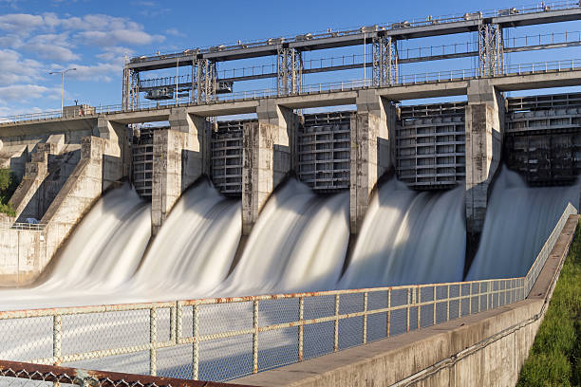

**Name:** Lee Jin Yan (103706958)

Lee Wen Heng (103698372)

Chea Eu Jin (103710357)

**Link:**

**Due Date:** 18 November 2022

**Unit:** COS30045 Data Visualization

Visual Analysis on Hydropower in Europe

Contents

**1.** **INTRODUCTION** 2

**1.1** **Background and Motivation** 2

**1.2** **Project Objectives** 2

**1.3** **Project Schedule** 2

**2.** **Data** 3

**2.1** **Data Source** 3

**2.2** **Data Processing** 3

**2.3 Data Transformation** 3

**3. Requirements** 4

**3.1 Must-Have Features** 4

**3.2 Optional Features** 4

**4. Visualization Design** 5

# **INTRODUCTION**

## **Background and Motivation**

The aim of this assignment is to educate the public about the information for sustainability energy which our group selected is hydro-power plants in the Europe region. The use of this dataset provided by the Nexus project at the European Commission’s Joint Research Centre (JRC) is to view the overall power system modelling purposes and publicly available sources. From the view of dataset in tabular form, audience are very hard to understand since it is lack of visualization which can help the audience to compare each of the nation hydro-power plants Is greater in details and finding the typology of the power plant either from run-of river, reservoir based or pumped storage able to produce best backup power during major electricity outages or disruptions.

## **Project Objectives**

The goal of this project is to make it easier for people to discover which hydro-power plants able to produce the best result and hydro-power plants suit each of the nation in the Europe.

To accomplish this, I will visualize hydro-power plants using a parallel coordinate chart and make the website available to user via the internet.

The website will let users:

* Finding the **typology of the power plant** either from run-of river, reservoir based or pumped storage.
* Compare each of the **country** hydro-power plants Is greater.

The benefits of completing all these objectives in one comprehensive visualization is that anyone finding the typology of the power plant or comparing different brands of hydro-power plants of different country will b able to easily access data and interpret that could tell them the Typology and the country on the hydro-power plants in Europe.

The visualization could be helpful to all the country leader or people who support sustainability energy to help theirs answer the following questions:

* **What is the Hydro-power plants situations in the Europe?**
* **Which Country have the better Hydro-power plants?**
* **What the different between each of the typology of the power plant?**

## **Project Schedule**

The overall structure of the development of the project involved weekly stand-up meetings where the team discusses on the task progress and what they have contributed to the project. If there are any issues happens throughout the project such as team members lack of contribution or are conflict between the task, then they need to discuss in these meting so that they could resolved the matter.

Bigger meetings include the project stand-up meetings which allow for us to discuss our implementation and ideas. These meetings ensure that we are not deviating from the main topic as well as discussing if our design for the visualization is appropriate or could be improved. Feedback during these meetings is essential for building the projects for user that struggle to understand the visualization or having trouble on the data.

# **Data**

## **Data Source**

The data used for this visualization will consist of basic information on all the European hydro-power plants on 2019 source from Nexus project at the European Commission’s Joint Research Centre (JRC). This data is in tabular form and consists of the following attributes.

(Dataset: European Joint Research Centre, ‘JRC Hydro-power plants database’)

|  |  |  |
| --- | --- | --- |
| **Attributes** | **Description** | **Type** |
| id | This fields contains ID of the power plants | Categorical (Text) |
| name | This field contains the name of the power plants | Categorical (Text) |
| installed_capacity | This fields contains Installed Capacity | Continuous (Numerical) |
| pumping_MW | This fields contains pumping capacity | Continuous (Numerical) |
| type | This is a field contains of the typology of the power plants | Categorical (Text) |
| country_code | This is a unique code that represents the indicator of a country | Categorical (Text) |
| lat | This field contains the Latitude | Continuous (Numerical) |
| lon | This field contains the Longitude | Continuous (Numerical) |
| dam_height | This field contains the nominal height of the dam | Continuous (Numerical) |
| volume_Mm3 | This field contains size of usable reservoir in millions of cubic meters | Continuous (Numerical) |
| Storage_capacity_MWh | This field contains maximum storage capacity in MWh | Discrete (Numerical) |
| Avg_annual_generation_GWh | This field contains annual Average/ Expected Generation in GWh | Discrete (Numerical) |

## **Data Processing**

This dataset will only require some basic transformation to enable visualisations to correctly display the data will involve of excel procedures and the use of calculation. In order to answer some of the questions identified under projects objectives., a few calculated fields will need to be made, such as the sum of the power plant in each country, this will utilise excel functions and transformations.

## **2.3 Data Transformation**

The first step in preparing the data for visualization was to remove unnecessary data attributes from the Microsoft Excel, there are a lot of data in the attributes that are blank so we could decide to put as NULL or delete the attributes.

The next step was to add in an extra column for the sum of power plants in each of the countries. This new attribute is Discrete (Numerical). A VLOOKUP excel formula was used to retrieve the associated ‘Total’ value from the metadata-indicator sheet using the ‘Country Code’ as the lookup value.

## **2.4 Project Timeline**

|  |  |  |
| --- | --- | --- |
| **Week** | **Activities** | **Member contributed** |
| Week 1 | Choosing group name and title for visualization project | Lee Jin Yan, Lee Wen Heng, Chea Eu Jin |
| Week 2 to 4 | Looking for suitable dataset | Lee Jin Yan, Lee Wen Heng, Chea Eu Jin |
| Week 4 | Preparing slides for Standup 1 | Lee Jin Yan, Lee Wen Heng, Chea Eu Jin |
| Week 4 to 9 | Researching on suitable programming language used for displaying the visualization | Lee Jin Yan, Lee Wen Heng, Chea Eu Jin |
| Week 10 | Drawing low fidelity sketches for visualization charts/graphs | Lee Jin Yan, Lee Wen Heng, Chea Eu Jin |
| Week 11 | Standup 2 presentation | Lee Jin Yan, Lee Wen Heng, Chea Eu Jin |
| Week 12 | Start to work on the code to display the visualization on localhost | Lee Jin Yan, Lee Wen Heng, Chea Eu Jin |

# **Requirements**

## **3.1 Must-Have Features**

These are features without which you would consider your project to be a failure. Were you able to deliver all the promised features? If not, explain why.

These are the features that we need to include in our project for the audience to interact with the visualization. Our group think we can produce all these features because we have learnt all these features and it is easy to implement on the website. The list of the features is presented below:

* **Title**: Lets the user know what the chosen visualizations are supposed to represent.
* **Axes & scale:** Used x-scale and y-scale to describe the variable of the chart. The marks on the axes are used in relation to the unit used.
* **Axes Labels:** Important to let the audience understand what the axes are representing.
* **Color:** Visualization should have different color so audience able to understand the chart quickly and understand the meaning the message of the color (red is negative, green is positive)
* **Explanation: Let** the audience understand how to use and read the data of the visualization.
* **Buttons:** Able to switch different transitions, chart and requirement

## **3.2 Optional Features**

These are the planned optional features we might include in the final visualization but not all will be implemented since these are just added functions which will not be affecting the project.

* **Mouseover/Mouseout**: Dive into more details about the event when the mouse moves between the elements and mouseout when it leaves.
* **Transitions:** Different animations change over a period.

# **Visualization Design**

**Bar Chart**

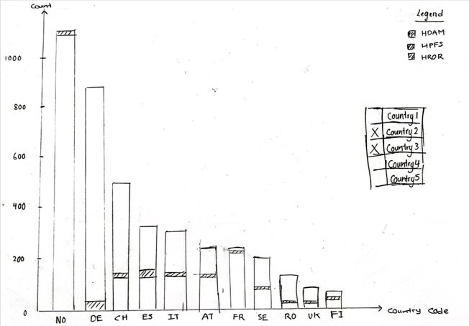

* Data Source (Count, Country_Code, Type of Power Plant)
* Calculate the type of powerplant in each country

The bar chart is a diagram which can represent the numerical values of variables to track on calculate the type of powerplant in multiple countries. With the help of stacked bar chart, it can compare numerical values of an attributes of a categorical variable and decomposition of each bar. In addition for audience to understand each of the meaning of the color, we added the color coded legend to identify the different bar series.

**Line Chart**

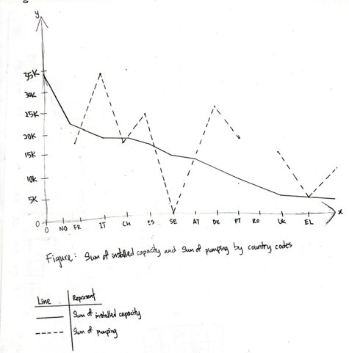

* Data Source (Country_Code, Installed_Capacity_MWh, Pumping_MWh)
* Finding the total maximum amount of electricity used in different countries

The line chart is used to show information about the total installed capacity and pumping capacity of the power plants for countries in Europe. Finding the value of electricity uses in different countries is treated as quantitative data and encoded through the position on the line. There are an option features we are thinking of implementing if we have more time which is tooltips for audience to reveal the exact data value for each point. In addition, the user should be able to filter out the countries using selection tools.

**Choropleth**

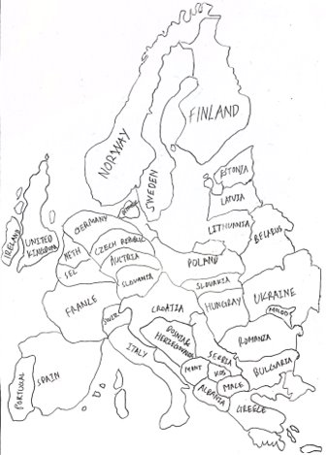

* Data Source (Count, Country_Code, Longtitude, Latitude)
* Per capita electricity from hydropower, 2019

In this map, which is in Europe region, it is shows that per capita electricity generation from Hydropower. The first feature that we intended to implement in the choropleth is the scale that allows user to understand the color representation in the countries (Darker color represents the electricity is higher). Next, we will add the tooltips to allow the audience to see the value that is represented in color. (Maybe include a button for year to show per capita electricity in different year)

**5 Validation [optional - Bonus Points]**

Test your visualization with users and report the results.

**6 Conclusion**

Provide a summary of the project and what you learnt from doing it.

In this project, our team have learned a lot of skills which are able to help us in the future industry on creating and making a better visualization for the audience. From this project, we also acknowledged that different types of energy production and consumption will bring up different environmental impacts like air pollution, climate change, water pollution, thermal pollution, solid waste disposal, and more.

**References**

References consulted (blogs, books, academic papers, discussion/help forums - for both design and programming)

European Environment Agency, 2004, ‘environmental impact of energy’ viewed on 31 October 2022 <https://www.eea.europa.eu/help/glossary/eea-glossary/environmental-impact-of-energy#:~:text=The%20environmental%20problems%20directly%20related,cause%20of%20urban%20air%20pollution.>